

**UNIVERSITY OF ASIA PACIFIC**

**Department of Computer Science and Engineering**

Course Code: CSE 404

Course Title: Artificial Intelligence and Expert Systems Lab

Assignment No: 01

| Submitted By,  Name: Anowar Hossen Farvez  ID: 20201059  Section: A2 |  | Submitted To,  Dr. Nasima Begum  Assistant Professor  Department of CSE,  University Of Asia Pacific. |
| --- | --- | --- |

**Problem Statement:**  
Implement a basic family relationship tree structure of own family using Prolog. Write rules against degree and removal for up to 3rd degree and twice removed situations.  
  
**Tools:**1. Draw.io  
2. Notepad++

3. SWI-Prolog  
  
**Diagram:**

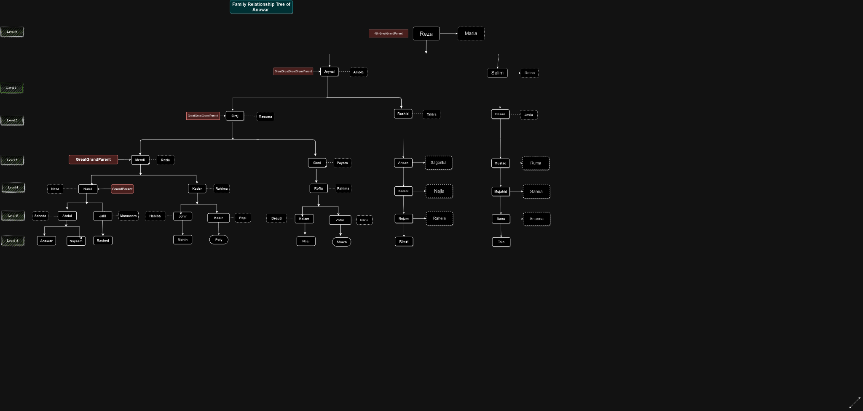

The above diagram is my family relationship tree structure. In the tree, all rectangular boxes represent males and dotted arrows represent wives.

**Source Code:**

**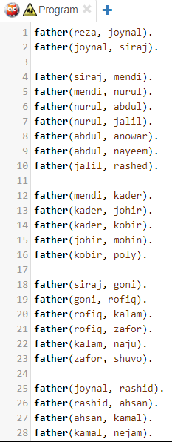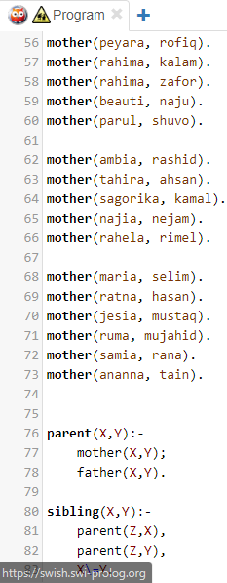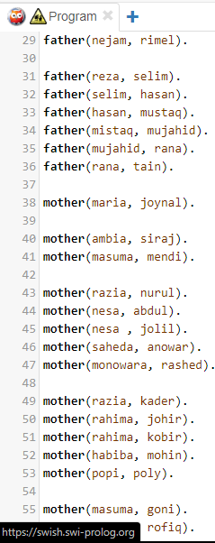  
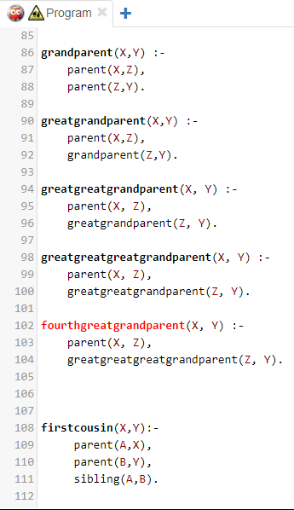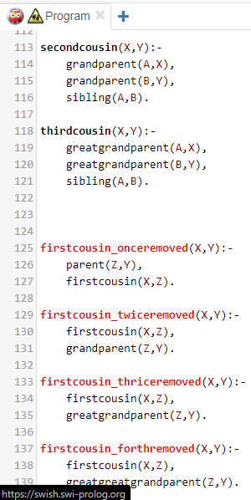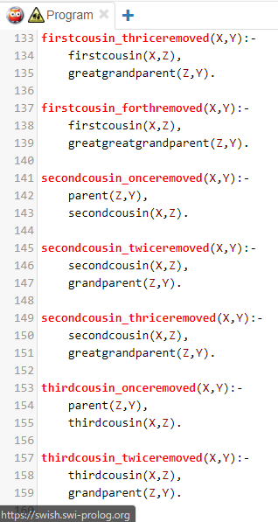**

**Sample Input/Output:  
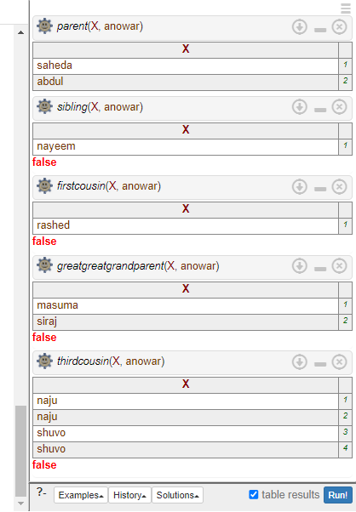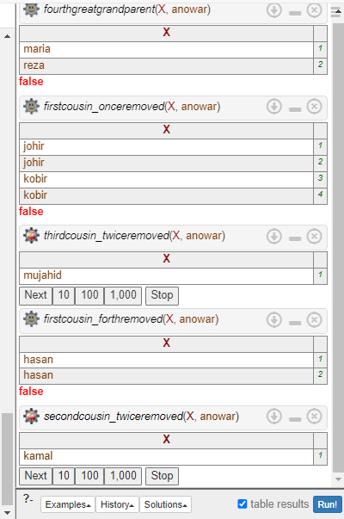**

**Conclusion:**

I’ve faced some minor difficulties during completing this assignment. SWI-Prolog was showing some errors. But after some troubleshooting I was able to fix all the errors of SWI-Prolog by using google and other sources.